SMDMM College and Rajarshi shahu Mahavidyalaya, Latur

Topic: "NIRF & AISHE : Role of Teachers in excelling performance of Institutions"

Date: 31/05/2020

College Logo:

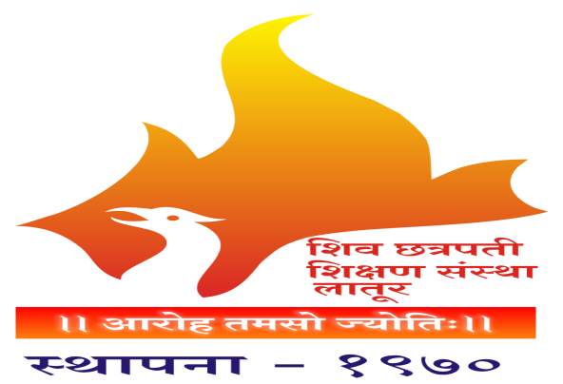

Principal: Dr.Mahadev Gavhane

Sign: 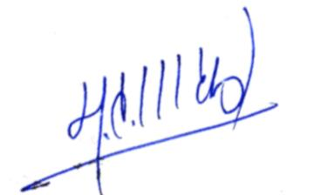

C

Coordinator: Dr Abhijit Yadav

Sign: 